WSI-INTERNET-EXCEL-LESSON02-CHARTS IN EXCEL - BASICS

**POINT 1 INTRODUCTION**

Often we need to illustrate our calculations with a chart- particularly when it is about different kinds of analyses and computer simulations. One chart is better than a thousand numbers. This lesson will provide step- by –step directions how to create basic charts in Excel.

**Learning effects**

Once the material of this lesson has been mastered, the student should be able to create basic Scatter or Pie Charts in Excel based on entered or acquired data.

**POINT 1**

**SCATTER CHART**



We need to create a table with data

In today's class we will work on a task for mathematical analysis class. The result of our work will be a common, standardized chart of five math functions.

We have a given function formula:

y = 2x2 - 3x - 2

x € <- 20 20>

1. The first step is to create a table with data which Excel will use to create a chart.

2. Fill in the table with a series of number values for x-s - dragging like while copying formulas:

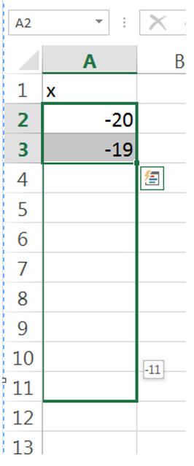

up to 20. . .

3. Fill in the values for y 1:

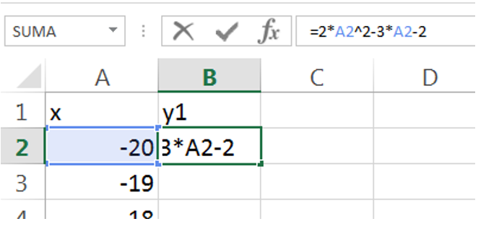

Then we drag the formula to the bottom, so that Excel calculates y for all x-s.

Creating and editing the chart

4. Having a ready table select values of all y-s and on the "INSERT" tab choose "SCATTER CHART ":

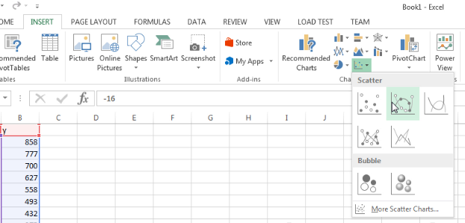

To draw charts of mathematical functions usually SCATTER CHART is used(position II or III). In this example we will apply position II.

Click on the second position and the chart will be created.

5. Unfortunately, the chart we have created is incorrect so we need to change the values of the data series. First, to make our work easier we need to move the chart to another worksheet. To do this, right-click on the chart and from the context menu select "MOVE CHART":

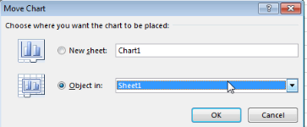

Select "Worksheet 1" and click "Ok". Automatically we will get moved to the second spreadsheet.

6. Now dragging the corners of the chart to the sides we can stretch it to full screen. This way it will be more comfortable. Then right-click on the chart and from the context menu choose "Select data". You will be moved to the first worksheet and the window "Select Data Source” will appear :

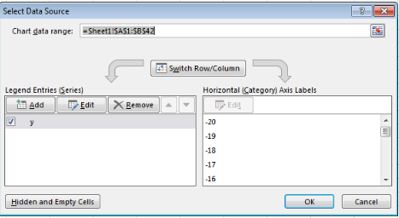

7. Select the "y 1" s and click the "Edit" button.

8. "Edit series" window will display.

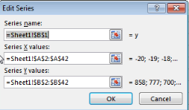

9. First select in the first text box "Name of series." We need to enter the name for the series. To do this, select the cell B1 (there we have entered the name of the series as "Y1"). So click on the graphical icon at the end of the form box and switch to the first worksheet (you can do this by clicking on the appropriate tab in the lower left corner of Excel window).

10. Now select cell B1 and again click on the icon at the end of the form box.



11. The next step is to provide the values of X series. At the beginning we go to the form box and click the icon at the end. Now select all values of X (from -20 to 20). And again, click on the icon at the end of the text box. Then click twice "OK". The chart will display correctly now.

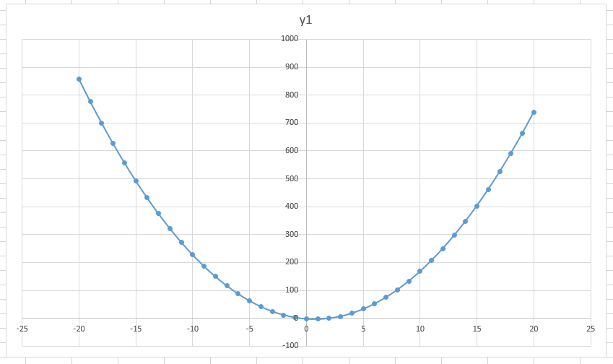

Add values of another function to the existing chart

12. At the beginning we have to add one more column to the existing table. We will call it y2:

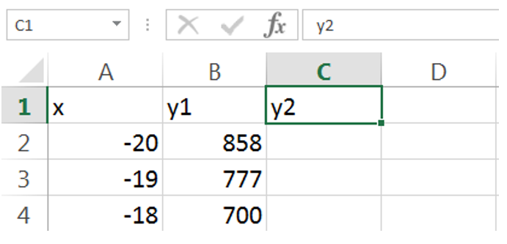

13 .The next step is to calculate y, according to the function formula.

Let’s say the formula is this: y2 = $\frac{x-1}{x+2}$

It should be noted that the argument of the function -2, does not belong to the domain. Later you will find out what to do about it.

14. Enter the appropriate formula in the cell C2 and drag it to the bottom so that Excel calculates the values of y2 for all x-:

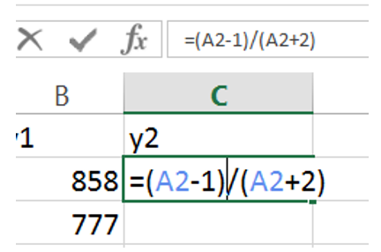

15. In the cell C20 the message "# DIV / 0!" is displayed which means that you cannot divide by 0. To get the chart drawn correctly, the cell C20 shoul be left empty, delete its contents by using "Delete" button.

If while executing the tasks, messages "Number" or "DIV / 0!" are displayed , we delete them leaving a given cell empty.

16. Having prepared the table, right-click on the graph and select from the context menu the option "SELECT DATA ...".

17. Then click "Add" button and following the same pattern as for correcting data in the previous exercise, give the name of the series (cell C1), select the value of all x-s (from -20 to 20).

18. In the box "Values of Y series" delete everything that is typed and select all values of ​​y2. Double click "Ok".

19. It’s done now! We have added to the chart another data series called "y2".

20. Now to make the chart look better you move the mouse cursor on the axis and right-click. From the context menu choose "FORMAT AXES".

21. In the text box "minimum" enter value "-7" and in the text box maximum enter value "7"

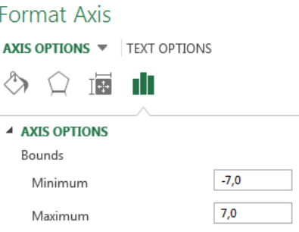

22. Click "OK". The chart is ready:

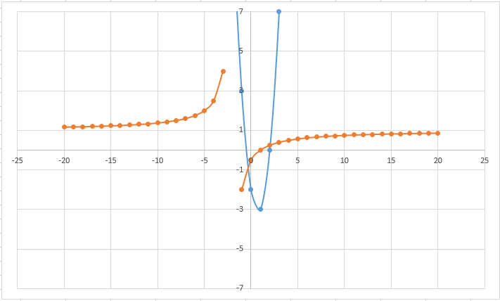

**POINT 3**

**Exercises**

To the created example add data series of function with a formula as below and move to the folder TASKS BY ...:

Homework

1. y3 = $\frac{\sin^{2}x}{x}$
2. y4 = $\frac{tg(x)}{x+1}$
3. y5 = $\sqrt[3]{x-2}$

**Checking knowledge:**

1. The data for the chart are taken from:
2. all selected cells
3. Selected cells, but only those in which there is a number
4. From cells with content (to be explained to students)

**POINT 4**

**Pie chart**

We were asked to prepare a pie chart with information about the most popular browsers in the world according to their percentages expressed in integral numbers - data for 2011. The leading browsers in the world are as follows (December 2011 according to the StatCounter website)

 Internet Explorer - 38,64%.

Google Chrome - 27,27%.

Mozilla Firefox - 25.29%.

Safari - 6.08%.

Opera - 1.98%

Others - 0.74%

Select the table and on the 'Insert' tab select the Pie chart and subtype 'Pie chart 2-D'.

2-D Pie Charts are clearer, unfortunately due to the attractive form of 3-D Pie charts they have become much more popular and the audiences expect them.

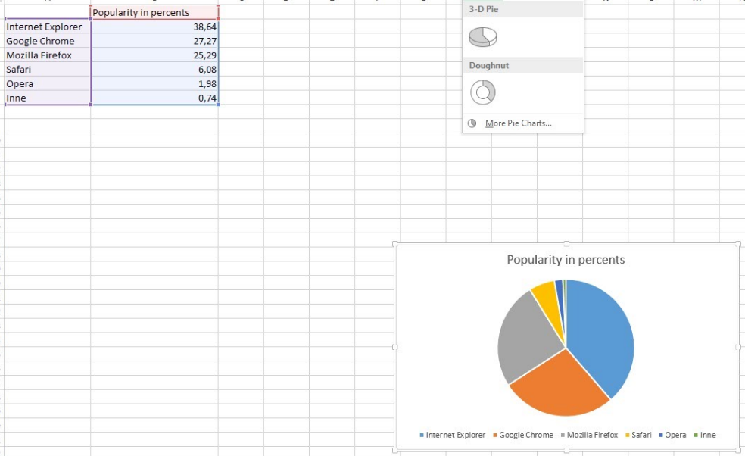

Finding products using small squares with their colors in the legend is very tiring, and when there are a lot of elements or if someone finds it hard to differentiate similar colors it becomes almost impossible impossible.

Click on a '+', uncheck the 'Legend', select the 'Data Labels', then click an arrow at the 'Data labels' first select the 'End of an external' and 'More options ...'.

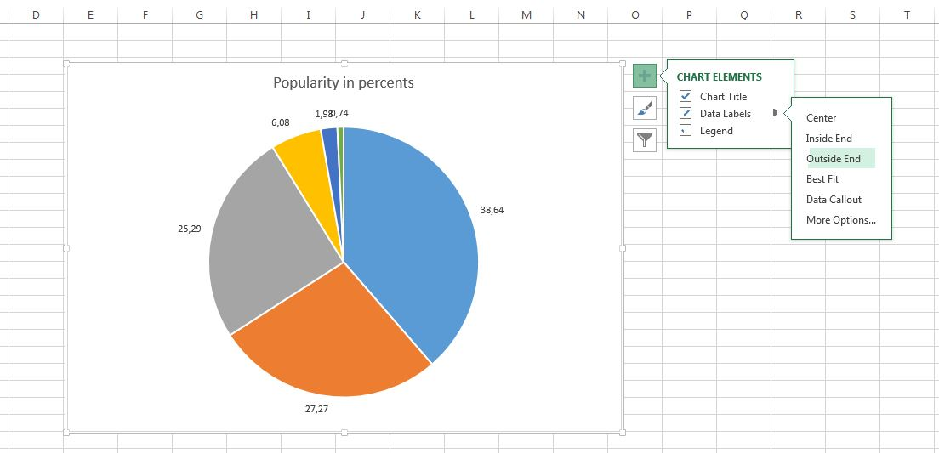

In the 'Format Data Labels' mark:

- 'Category Name' - so that we know which part of the pie applies to a given product.

- 'Percentage' - here there is calculated and given an approximate percentage of the total figure

Uncheck:

- 'Value' - in order to eliminate unnecessary decimals

There is a default option 'Show lines leading' - useful for large quantities of pie slices, so that the lines leading the clippings labels are connected.

Both messages displayed on the labels are separated by new line marks, and we can change it in the 'Separator' menu.

In this window, it is also possible to change the position of labels and change the format of numbers.

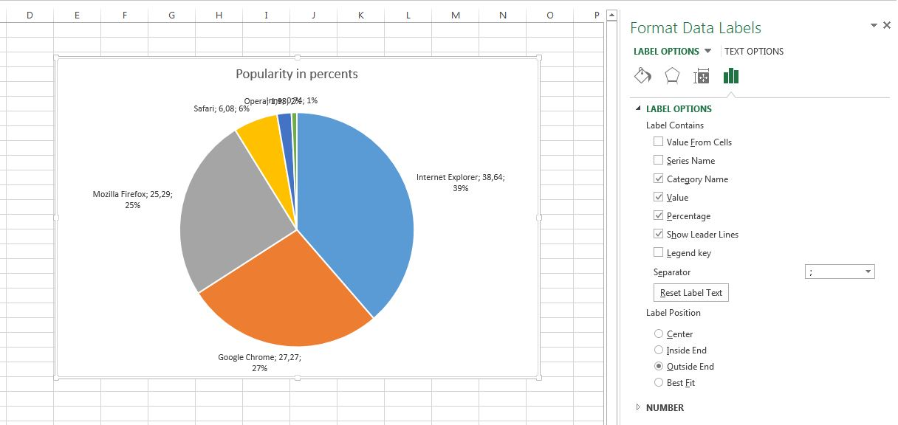

As in all charts we can also use the styles and colour palettes, which are available when you click the Brush icon.

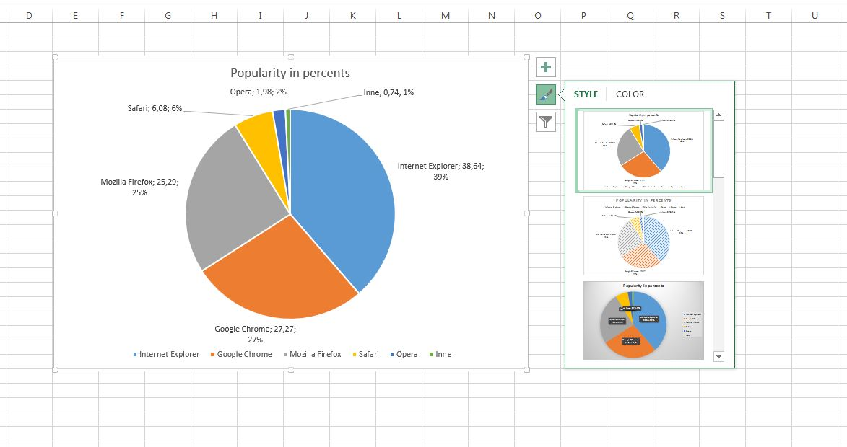

A colour slice can be changed by clicking on it twice individually (with a break between clicks) which will result in the selection (small circles), then click it with the right button and choose the colour changes which are visible on the chart when you move the mouse cursor over the colours.

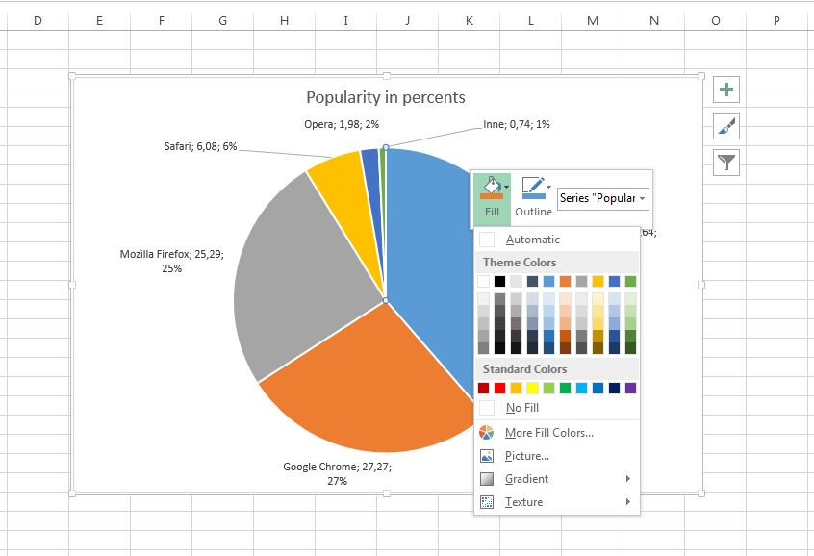

To eject the selected clipping simply select it and drag it from the centre of the chart. It is used to draw the attention of the recipient precisely on this passage.

After bolding the data labels and writing the title, the chart will look like in the figure below.

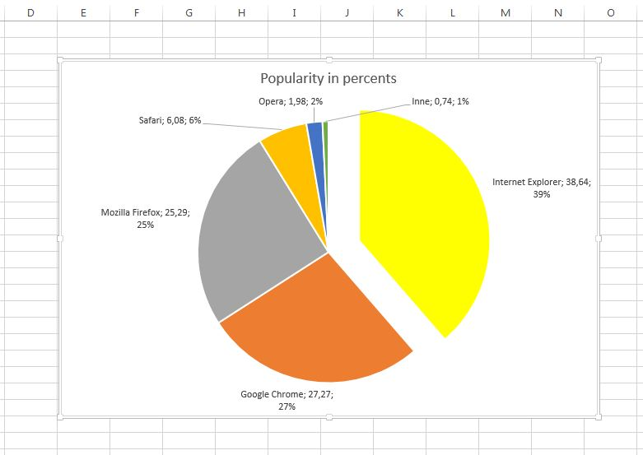

In order to get rid of the graph frame right click it, and choose the command 'Format chart area ...'

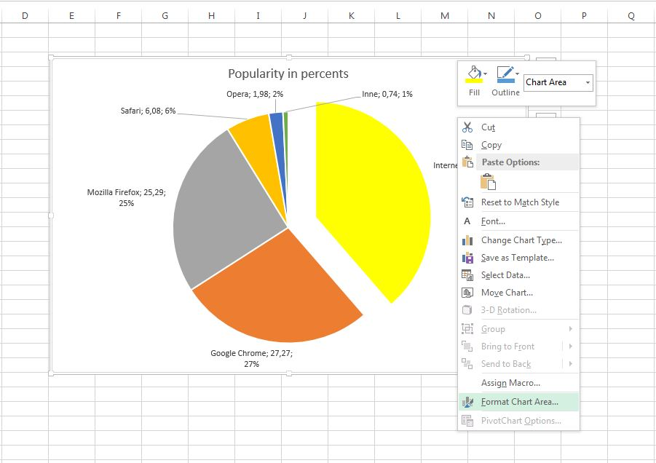

In the 'Format the Chart ' window choose 'No Line'. Close the window.

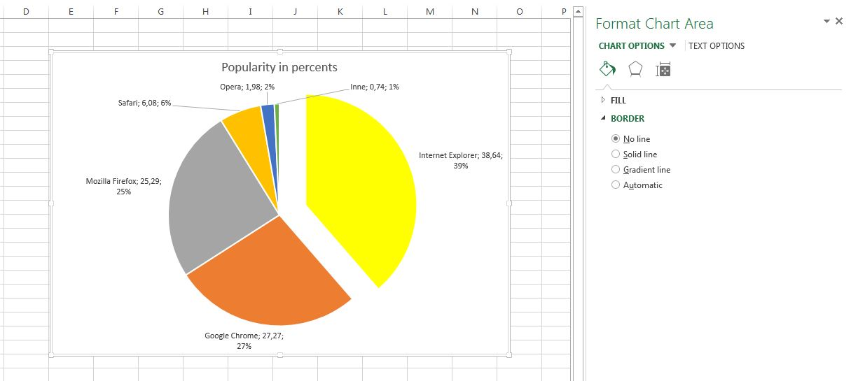

At any time we can change the chart type by right clicking and selecting 'Change the chart type ...'.

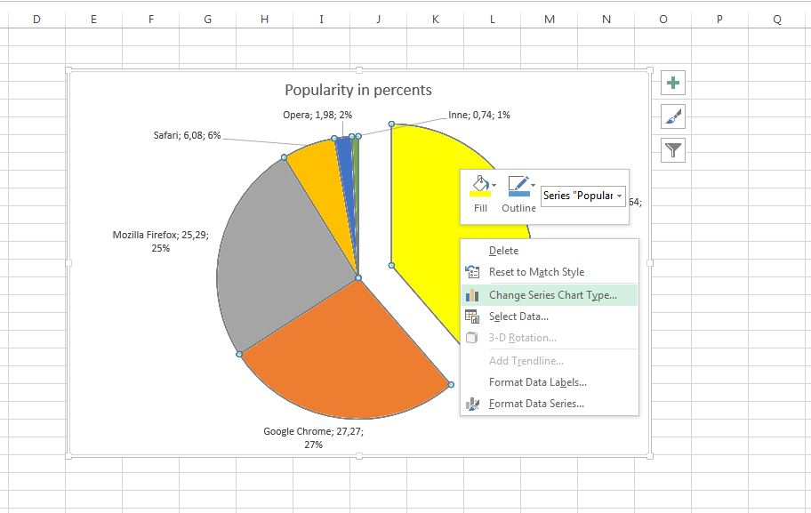

Now let’s choose a 3-D pie chart.

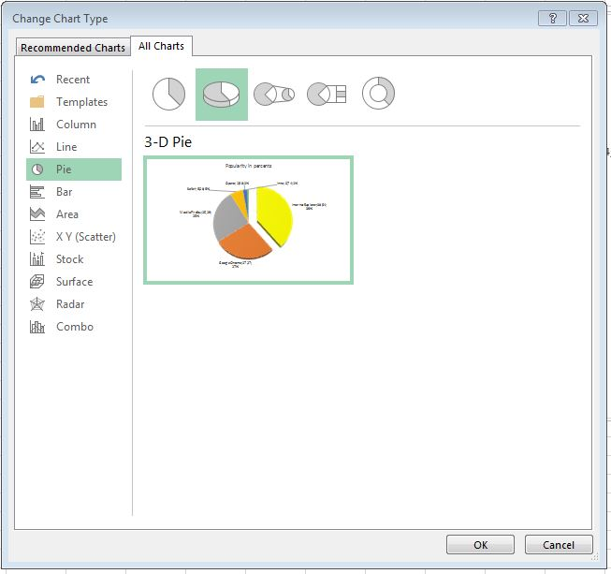

For 3-D charts, there are many styles, you have to adjust yourself the right one for the job.

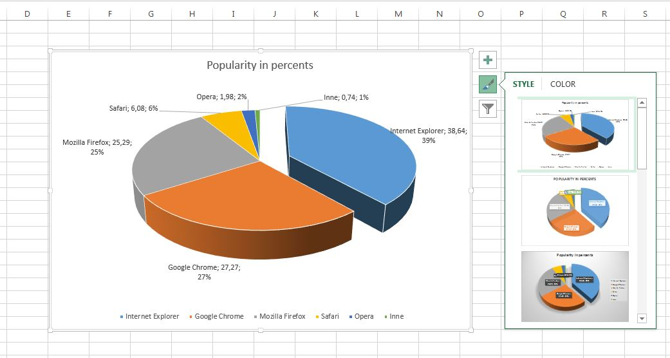

By right clicking the chart and selecting 'Rotate 3-D' we will be able to choose how to position the chart, which will highlight the fragment we want.

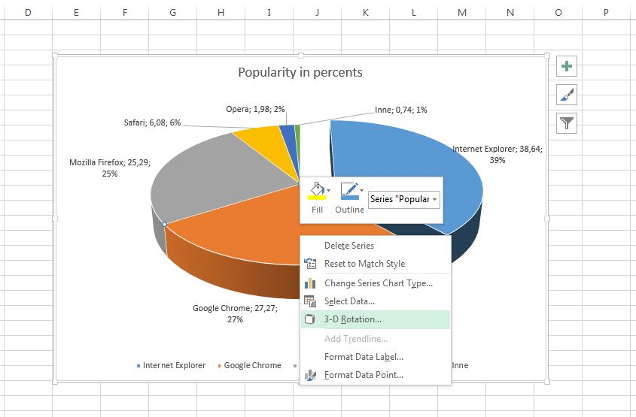

WARNING:

Increasing Prospects makes the graph less clear, and the section which is at the bottom seems larger than it actually is.

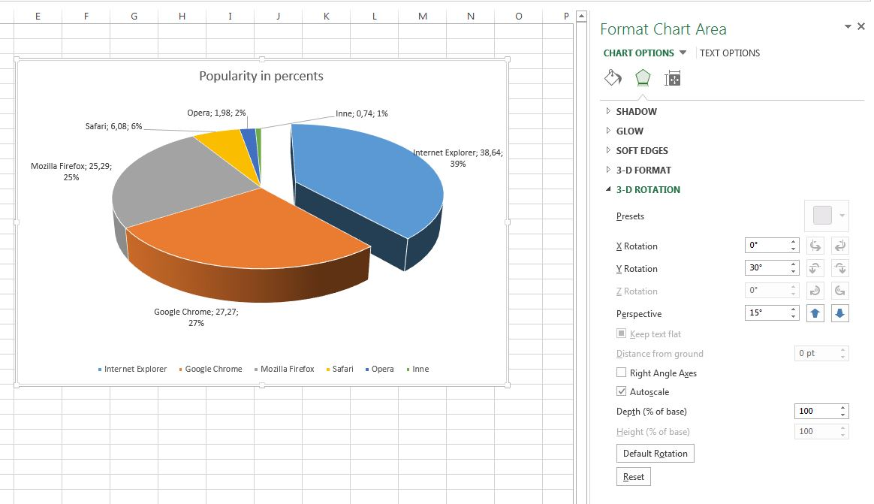

CHECKING THE KNOWLEDGE:

Graphs can be displayed:

a) Only in the spreadsheet where the data comes from

b) Only in the data spreadsheet and chart spreadsheet

c) You can view ae graph in each of the existing spreadsheets and make it a spreadsheet of the chart

5. Summary

In the lesson we presented the basics of creating charts in Excel. Once you have mastered the material you should be able to create charts in Excel. This of course does not cover the whole subject of charts therefore we encourage self-experimentation.